UBC Arts Co-op Hub Design Project Part 2

By Michelle Lee, Renée Choquette, Austin Lam,
Brandon Lee, and Wilson Lee

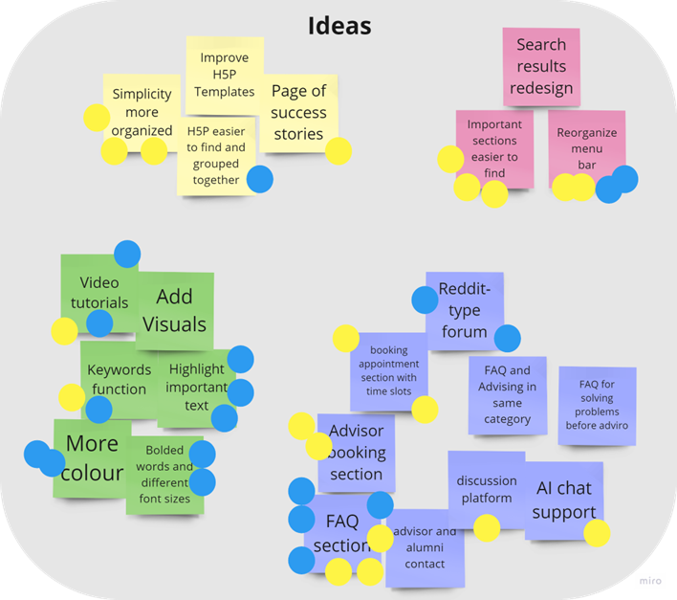
- Ideas

There are four main areas that our ideas focused on when we came up with ways to address the UBC Arts Co-op Hub’s pain points that users identified during Design Part 1; the use of interactive H5P tools, design of search tools and menu bars, adding visual variety to the pages, and simplifying the means for students to ask questions and get help through the website. The ideation process consisted of the group brainstorming ideas they had to improve the UBC Arts Co-op Hub website. Each member wrote down ideas, then they were sorted into themes and focused to avoid repetition. There were obvious patterns identified in the ideation process as to which pain points need to be addressed. Some ideas were more feasible for our group to implement change and improvements, and although we decided to focus on those, we kept “bigger ideas” on the board for the sake of discussion.

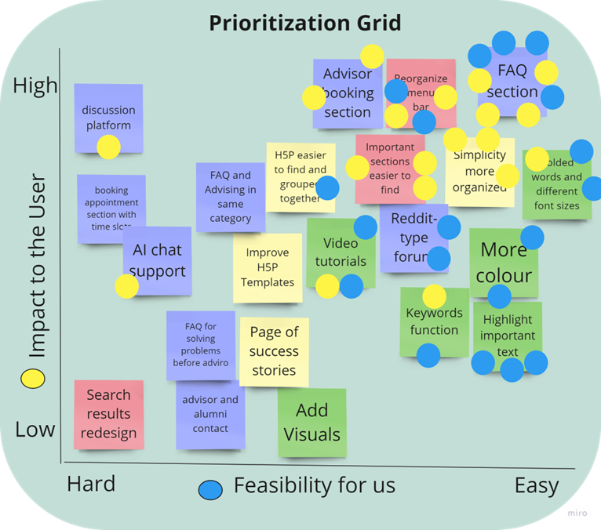
- Prioritization Grid

Based on the group’s voting on the ideation process and choosing ideas to implement for the UBC Arts Co-op website, we chose a few main ideas to focus on and combine the feasibility of the design and their impacts on the user. We selected ideas that were both easily implementable by our group and would greatly impact the user. The ideas that got the most votes and that the group thought would be best to focus on were creating an FAQ page where all questions were accessible to the user in one place, reorganizing the menu bar and making important sections easier to find, creating an advisor booking page, so users can make appointments with an advisor when they need questions answered, and overall better use of color and organization of the text.

- To-Be Scenario
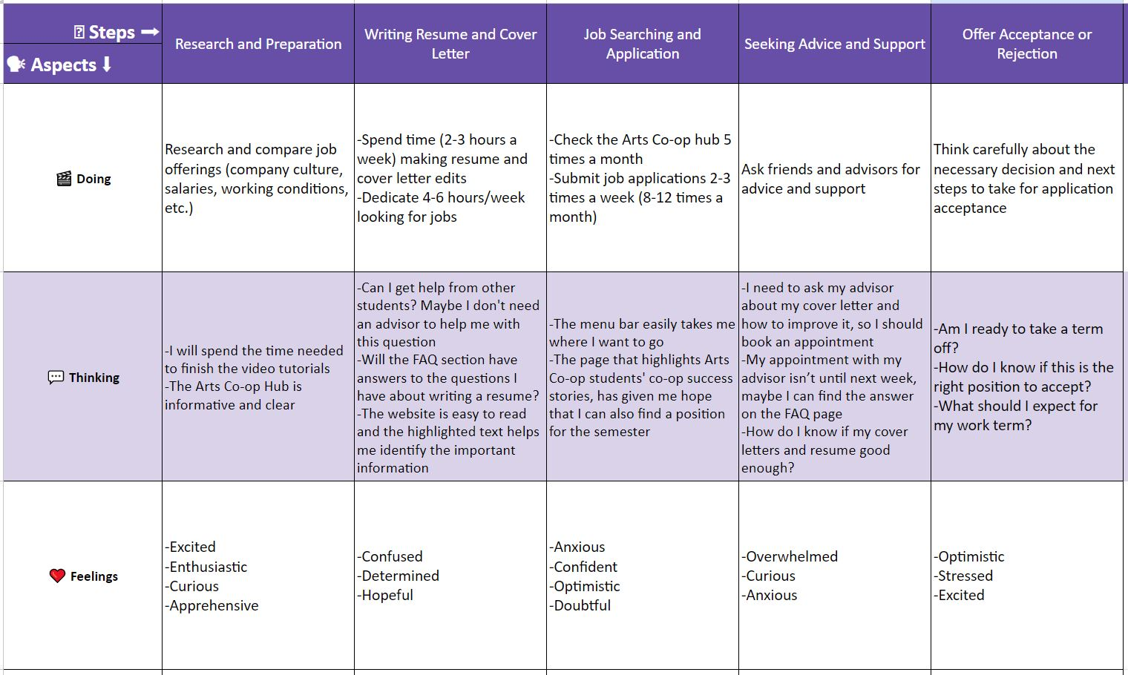

- Low-Fidelity Prototype
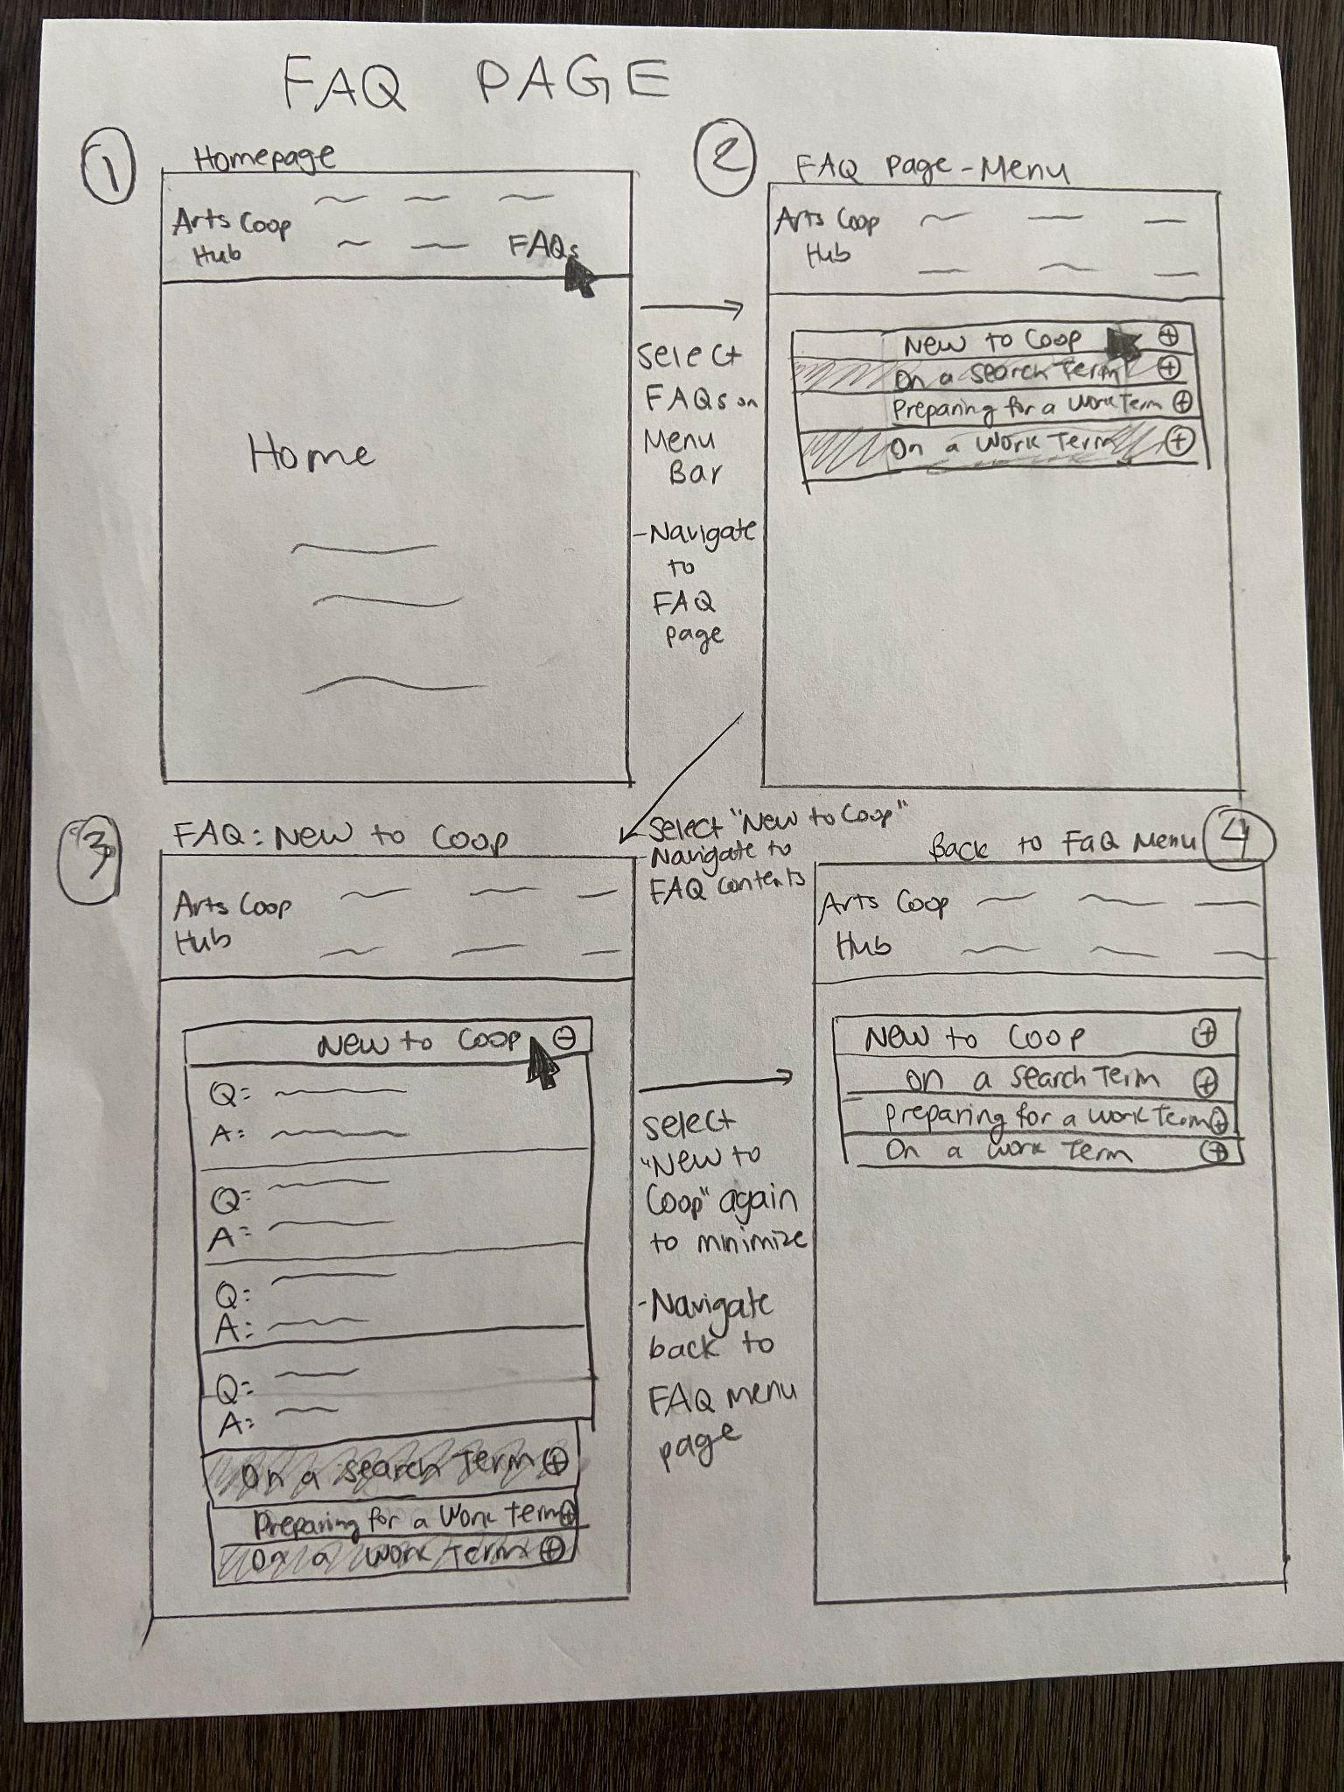
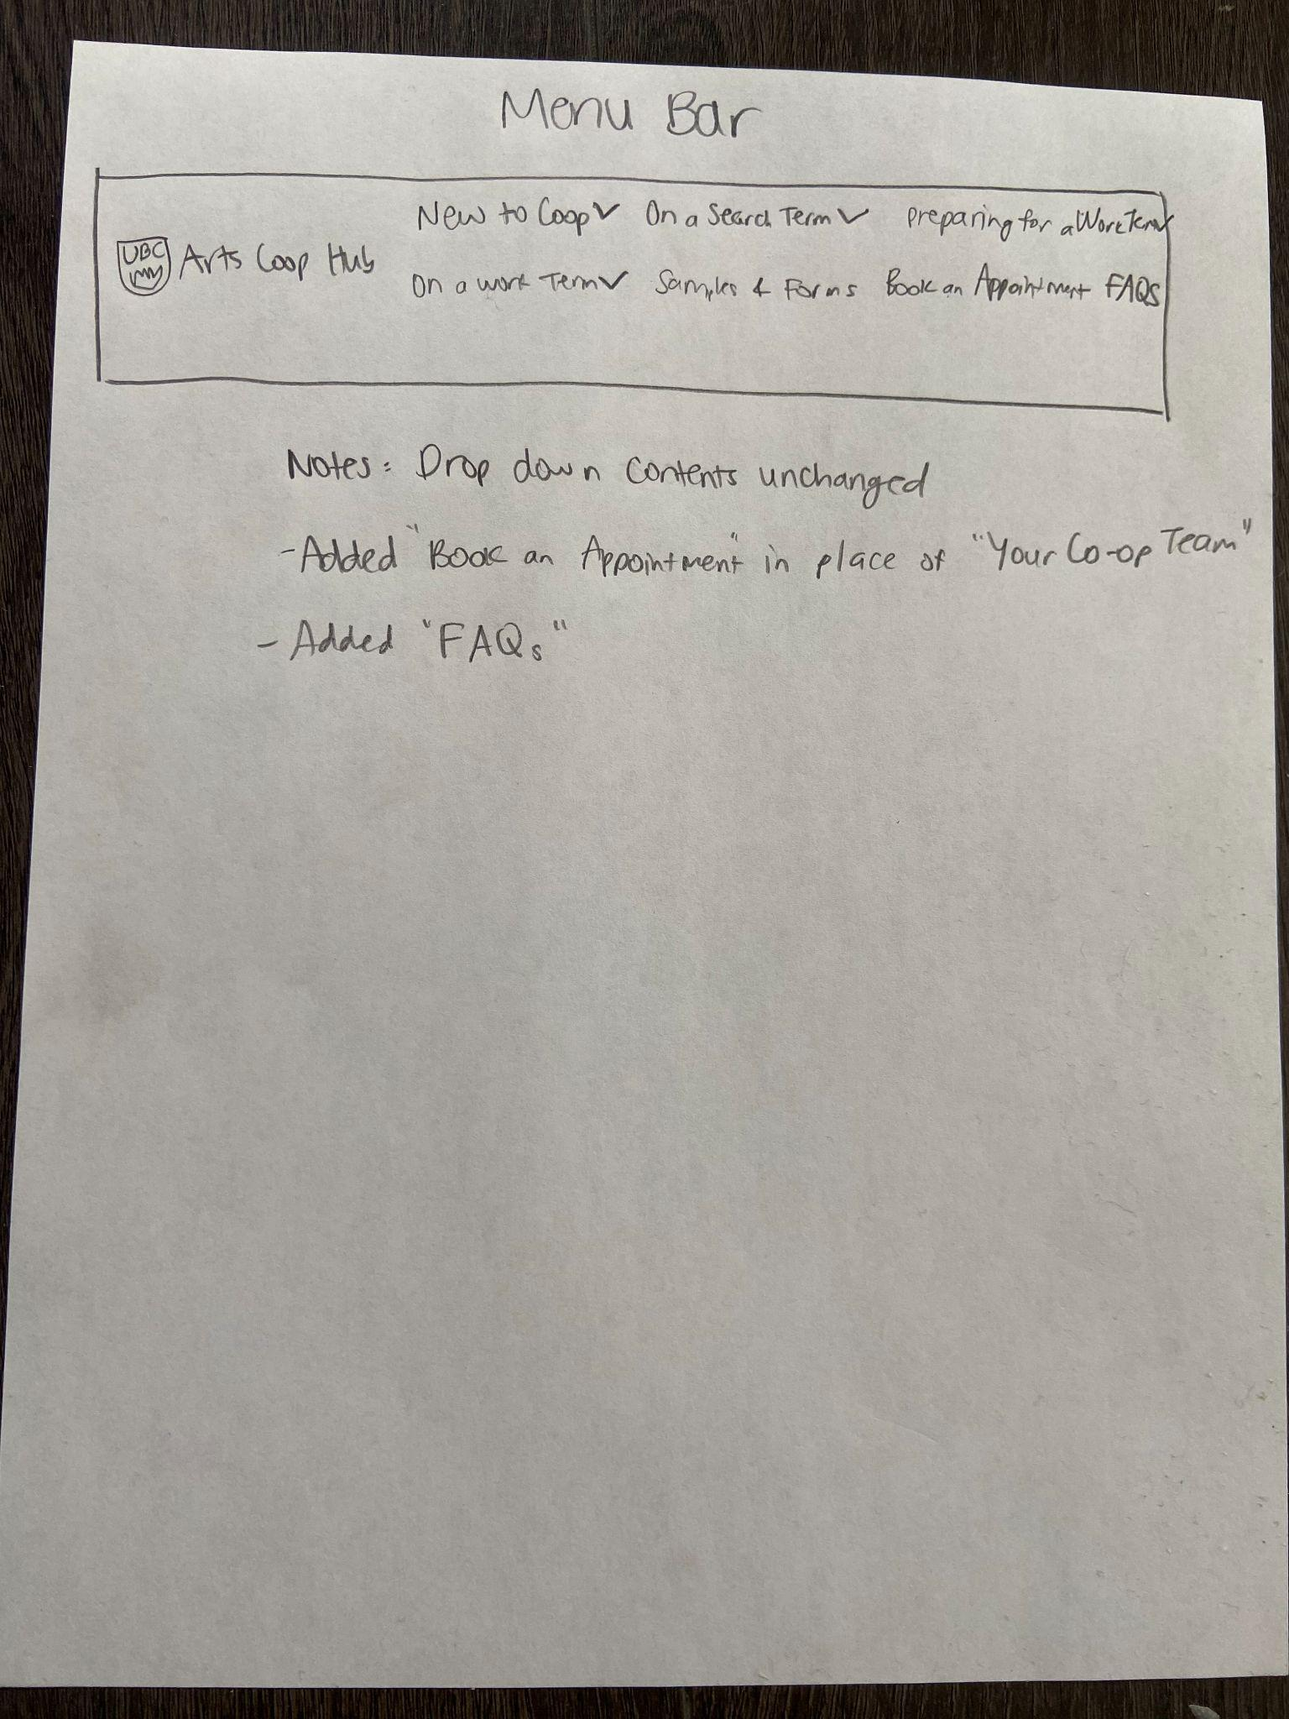
  - Prototype

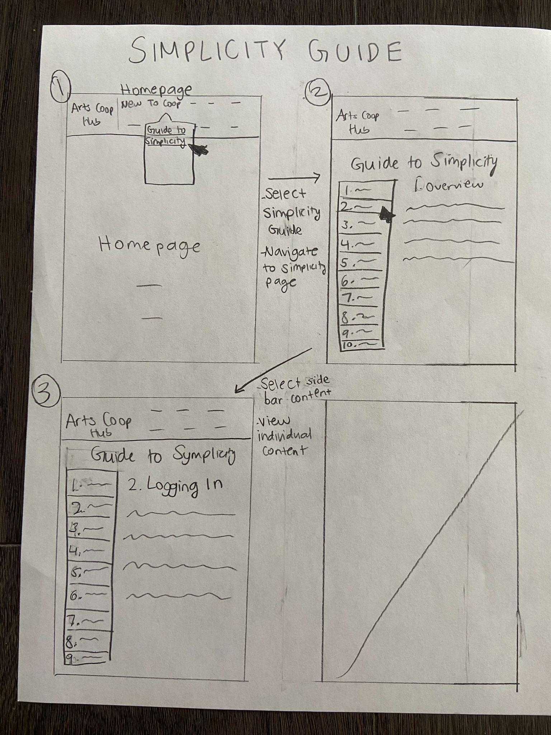

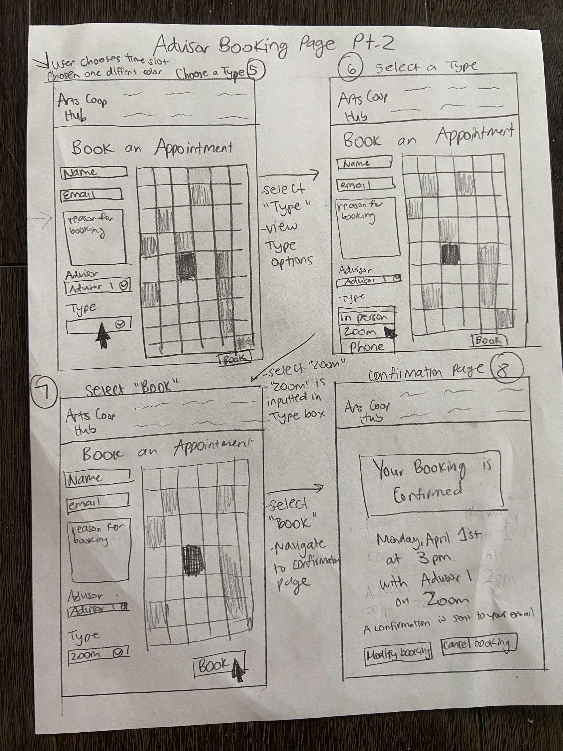
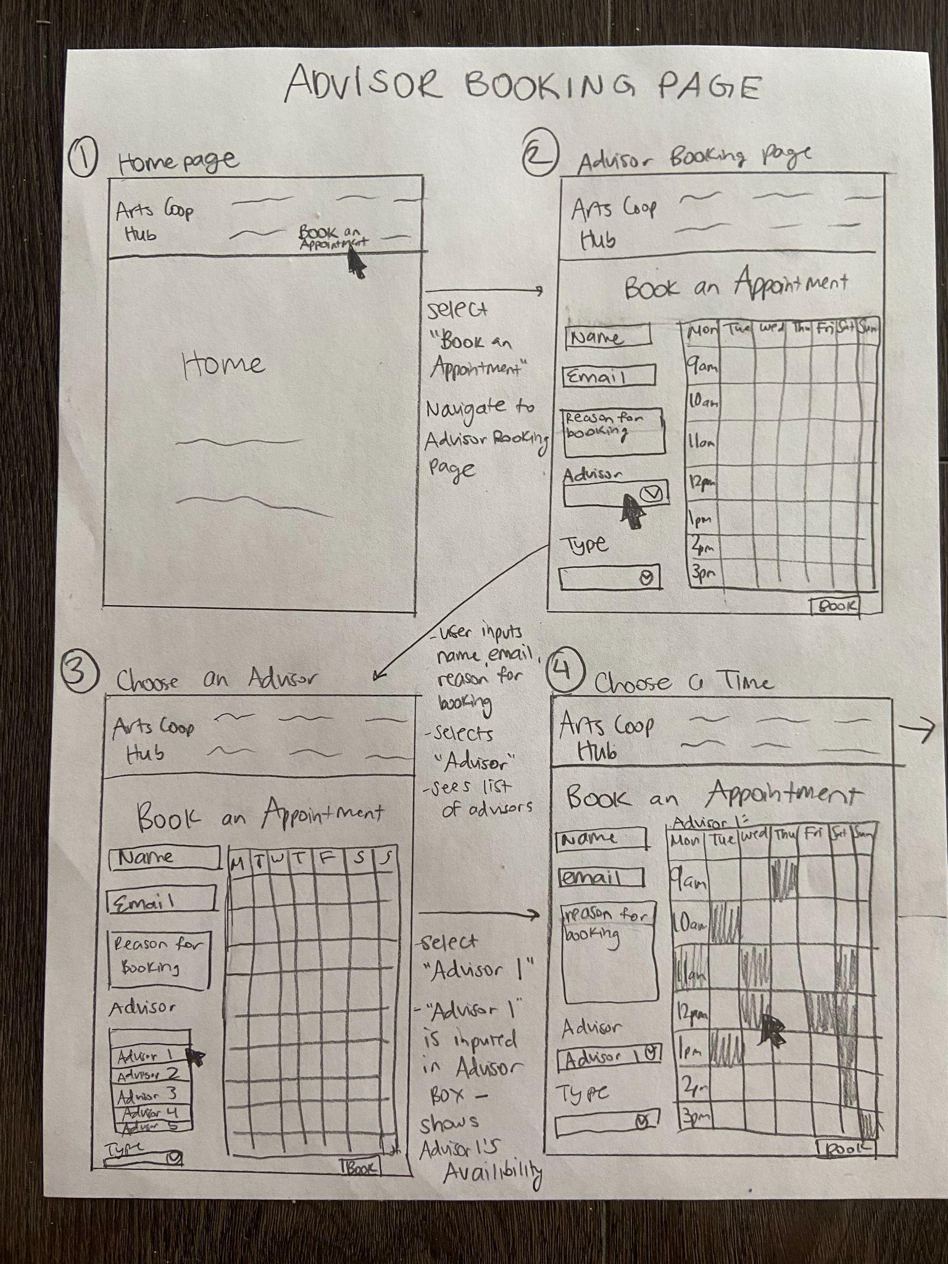
  - Lean Evaluations

Representative Description | Evaluation Method | Feedback
Second work term  Female  20 yr old  3rd yr BMS + MM | Used the lo-fi prototype to simulate using our new features:  1) navigating through the dropdown menu and sidebar menu  2) looking through the FAQ  3) booking an advising appointment | -really loves that she can see all the submenus on the new sidebar menu; much easier to find information than clicking on many different submenus  -for the FAQ Page, she prefers a sidebar like the simplicity sketch  -likes that the FAQ is divided into the categories as the Hub drop down menu  -likes that she’d be able to book an advising appointment on the Hub  -likes how she can easily see availability for the advisor booking page
First search term  Male  21 yr old  3rd yr BMS | “ | -for the menu bar, he thinks we should keep “your co-op team and l just add advisor booking in the drop-down menu” because he’d want to see the co-op team  -likes that the new drop-down menu has less stuff and that he can see all the menu options in the sidebar menu  -likes the idea of the FAQ page  -suggests that we can add information on how to navigate the Hub and/or Symplicity on the FAQ  -likes the calendar style availability layout of the advisor booking page
First search term  Female  22 yr old  3rd yr BMS | “ | -likes the sidebar menu because it takes fewer clicks to access/look for information  -suggests a hovering feature for the sidebar to make the search for information even quicker  -prefers a sidebar for FAQ page like the simplicity sketch because less clicking  -likes that she easily see the availability for the advisors for the Advisor Booking Page  -prefers the Advisor and Type of Meeting options to be visible instead of a drop-down for the advisor booking page, so less clicking  -suggests a Google calendar invite in the booking confirmation for the advisor booking page

Summary:
For the most part, our representatives liked the new features implemented. They all thought that the decluttering of the dropdown menus, and adding a sidebar menu, made it much easier for users to find information. They seemed to be ok with the FAQ page, but had more suggestions than compliments, such as implementing a sidebar menu and adding more types of FAQs. Lastly, all three participants liked the advising appointment page. Most of all, they really liked how the calendar block style availability easily showed the advisor’s availability.

- Clickable Medium-Fidelity Prototype for MVP
Mid-Fi Prototype Link: https://www.figma.com/proto/HUdMYdKHzIKVke5y3pWmLk/Arts-Co-op-Hub-Prototype?node-id=1-5&scaling=scale-down&page-id=0%3A1&starting-point-node-id=1%3A5

Sequential Storyboard Link: https://www.figma.com/file/1nWwARCpoR0ygwJpdIU9U1/Untitled?node-id=0%3A1&t=qQ2MNJ8yEfNE5tmv-1

Our medium-fidelity was made on Figma, and based on the feedback that we received from our low-fidelity prototype. Users are able to navigate to three featured tasks: Guide to Symplicity page, FAQ page, and Advisor Booking page. From the lean evaluations of the lo-fi sketches, we learned that we should keep the menu items similar to the original, such as keeping the "Your Co-op Team" and adding the advisor booking section as a sub-menu item under that. The users like the idea of the general FAQ page, but prefer sidebar navigation to be implemented for the FAQ page, so we implemented a similar design structure to the FAQ page. The users enjoyed the new advisor booking page, and we implemented their suggestions such as less clicking for the user by making the appointment options listed out instead of a drop-down view. Furthermore, we implemented a “Add to Google Calendar” invite prototype button from a suggestion. We were not able to implement some of the suggestions, such as adding information on how to navigate the Hub and/or Symplicity on the FAQ page, due to time constraints and our lack of knowledge about Simplicity and even other areas of the Hub that were not our main focus.

  - User Evaluations
Rep 1
- Second work term
- Female
- 20 yr old
- 3rd yr BMS + MM
Rep 2
- First search term
- Male
- 21 yr old
- 3rd yr BMS
Rep 3
- First search term
- Female
- 22 yr old
- 3rd yr BMS

Evaluation:
Each Usability Testing Session was done by the interviewer giving the representative one or two tasks for the new ‘Simplicity Guide’ page (e.g., find ‘resume templates’). At the end of completing the tasks, the interviewer gave a brief explanation of each new feature and the changes that were made to the lo-fi prototype. Lastly, the representatives were given a chance to give feedback and look through / try out the Figma prototype.

Summary:
All three representatives were able to navigate through the three new features and complete the tasks quickly. For the ‘Simplicity Guide’ page, i.e. the new sidebar menu, the representatives all noted that the hovering feature (on the sidebar menu) made it even quicker to find specific resources than if they were required to click on each menu option. For the FAQ page, representatives noted that they liked the sidebar feature (that was added after representatives suggested implementing it from the lo-fi evaluations). However, they suggested adding more types of information to the FAQ, such as ‘Completing Co-op Assignments’ and ‘Co-op Requirements’. Lastly, for the ‘Advisor Bookings’ page, representatives noted that they liked the calendar feature that showed advisors’ availability. They also liked the new (advising appointment) confirmation page. A representative did wonder how this feature would overlap with the advising feature on Art’s Co-op’s other website—Symplicity.

There are still small kinks to work out for each feature, but overall, our three representatives thought that the implementation of these new features in the Hub would make it much more efficient and useful. In particular, the sidebar menu was a huge hit.

- Move Forward
  - Pitch
Are you tired of hunting for information on the Hub’s cluttered interface? Look no further than our new and innovative design! Our team has developed a more efficient website design that prioritizes speed, organization and user experience. Our redesign takes website navigation to the next level by utilizing an open sidebar menu, providing easy access to information. With our new intuitive design, users can easily search for information by hovering over the sidebar menu options. In addition to our streamlined navigation, we've also implemented an appointment scheduling feature that simplifies the process of booking appointments. With our block, calendar-style layout, users can easily view the availability of advisors and book appointments with ease. We've also added a comprehensive FAQ section that answers the most commonly asked questions about Arts Co-op, providing quick and easy access to information.
Say goodbye to the frustratingly cluttered layout of the Hub and hello to our more efficient and user-friendly design. Our website's focus on speed, organization, and ease of use will ensure that you can find what you need quickly and effortlessly. Contact us today to learn more!

  - Next Steps
If we keep developing our solution through another iteration of the design cycle. We will also create a search result design and discussion platform. Search result design is essential because it can increase accessibility. The search result design helps the website be more accessible to users by providing a simple way to navigate through a large amount of content. This is important for content-heavy websites where users struggle to find relevant information.
Also, a discussion platform can encourage user interaction since it allows users to engage with the website's content and with each other, which fosters a sense of community and encourages user-generated content. For example, when students are struggling with some problems, they can’t meet an advisor in the short term. The discussion platform can provide them with an opportunity to figure out with other students. Moreover, when the discussion platform runs over time, it can build up a wealth of user-generated content. It forms a valuable knowledge base for both new and existing users.

